Presentation on Jimma Bethel synod Evangelism work
To FLM
By Rev. Alemayehu Kebede
president
- Introduction
The Lord has done great things for us; whereof we are glad.
Ps. 126:3
Former Jimma Presbytery was established as a synod by the 19th General Assembly held on January 28-Feb. 2/2013 and it celebrated its 10th year birthday on the last April 2023.It is the fast growing synod among EECMY Synods even though surrounded by fanatic Muslim persecutors. It also serves more than 10 Ethnic groups. In addition, it is serving 5 marginalized minority groups namely: Manja, Tara, Bacha, Meniit, Nao and Mana (Potters).It has 10 presbyteries and 2 pre- presbyteries.
Now it comprises 90,564, total members, 49,722 communicant members, 203 congregations, 180 outreaches, 182 pastors (M=180, F=2), 182 evangelists and 31 volunteer evangelists. It operates its evangelism work in 2 Regional states i.e. Oromia Regional State and South West Ethiopia Regional State(SWERS) in 3 zones (Kaffa,Dawro and Konta) and in 1 Special woreda called Yem.
- Major activities being done by the support of FLM
As historical and longtime partner, FLM has a great concern to our synod. Accordingly, the following major activities are being done by the partnership of FLM currently:
1. Formal trainings
Theological trainings in certificate, diploma and degree
2. Informal trainings: seminars, conferences ….
3. MTC Building
III. Outcomes of the Partnership and the support of FLM
1. Getting more trained pastors and evangelists
2. Increasing number of membership
3. Increasing communicant members
4. Increasing the number of volunteer ministers
5. People are coming to Christ from Muslim community other religions
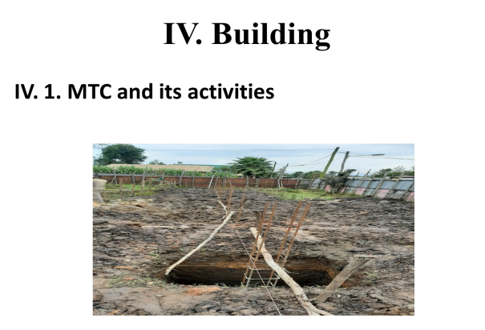
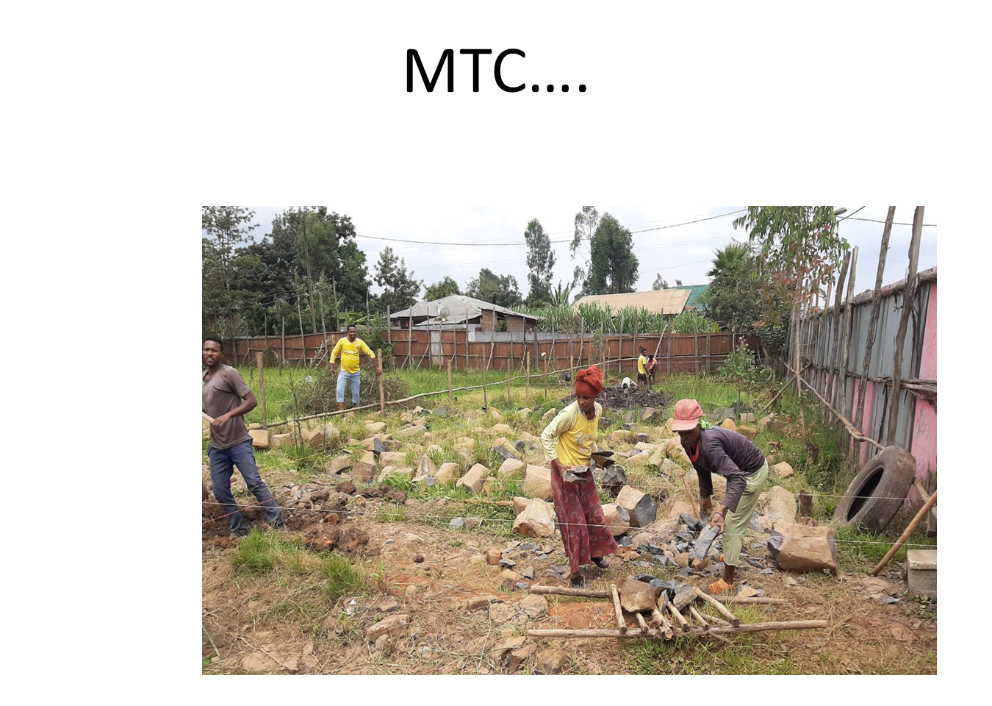

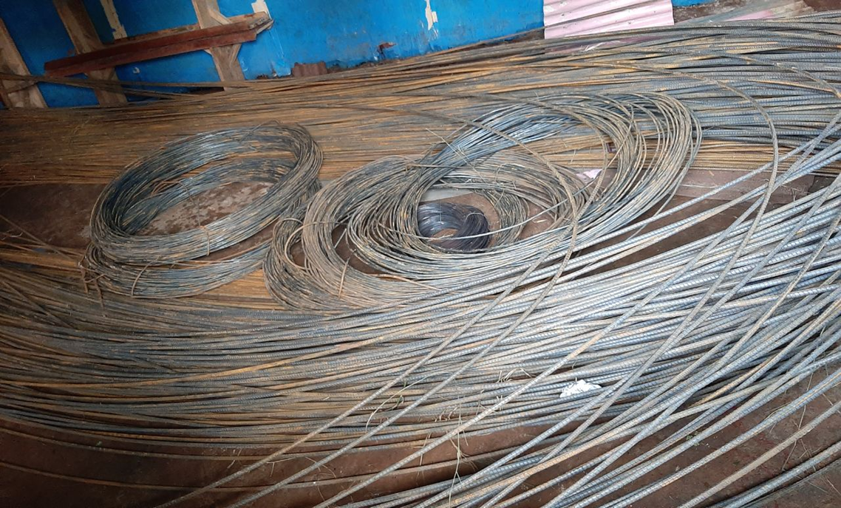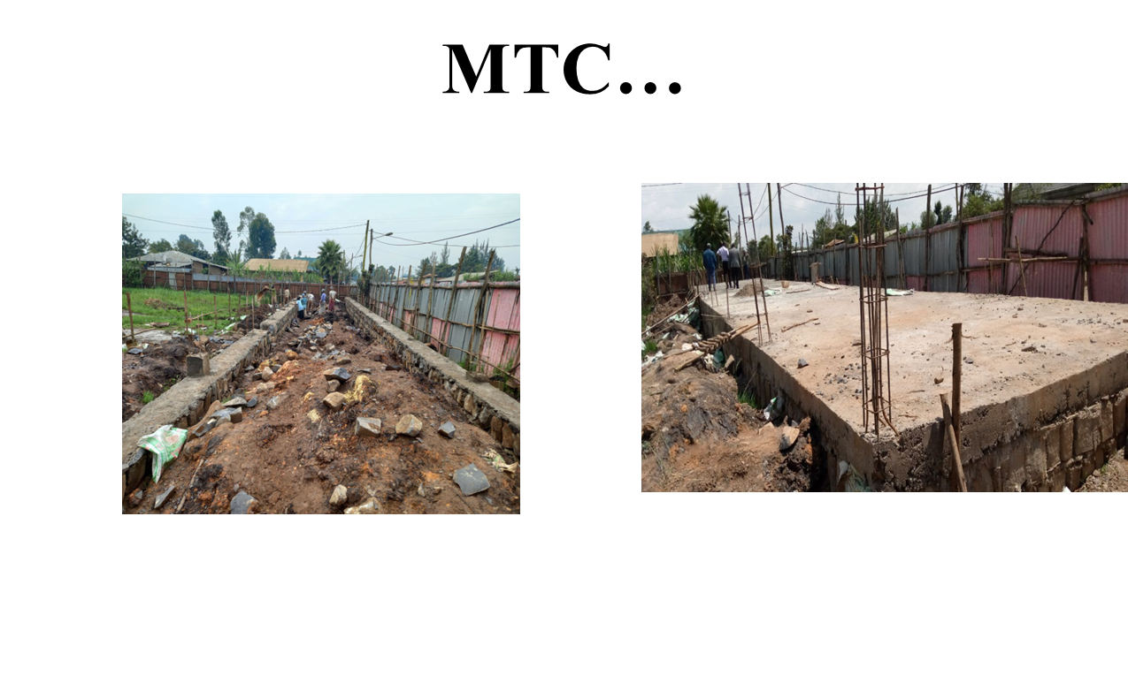
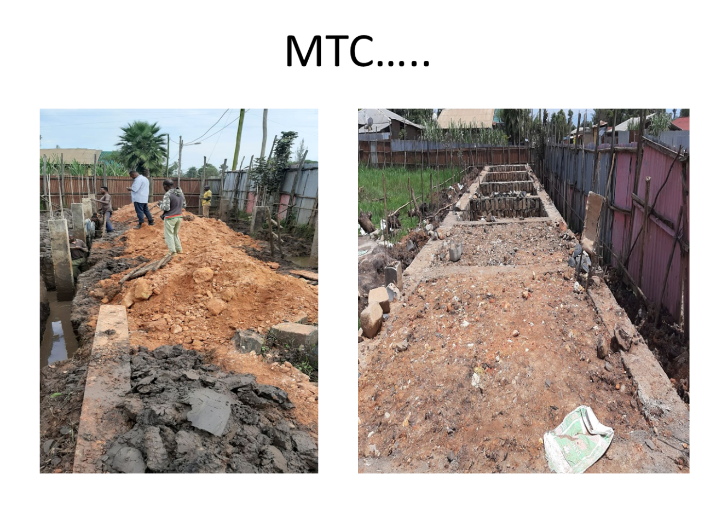

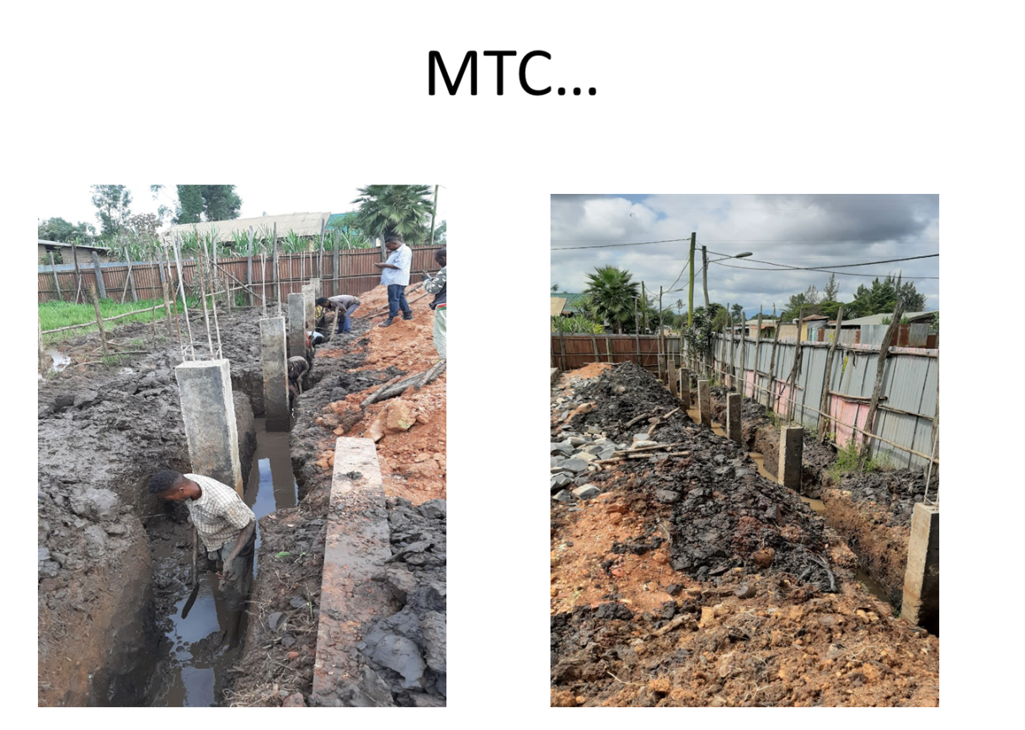
Leaders are following up MTC work
MTC…

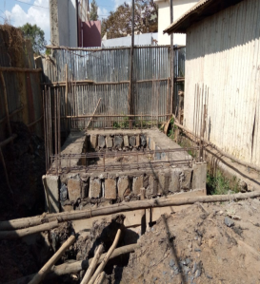
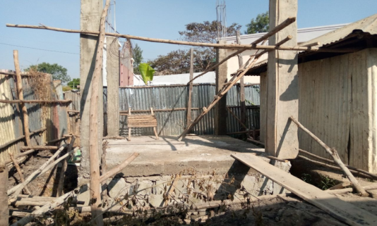
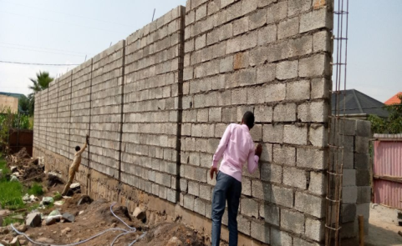
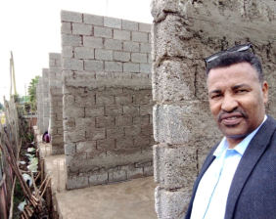

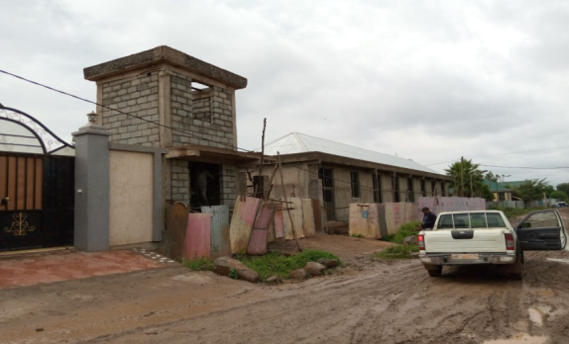
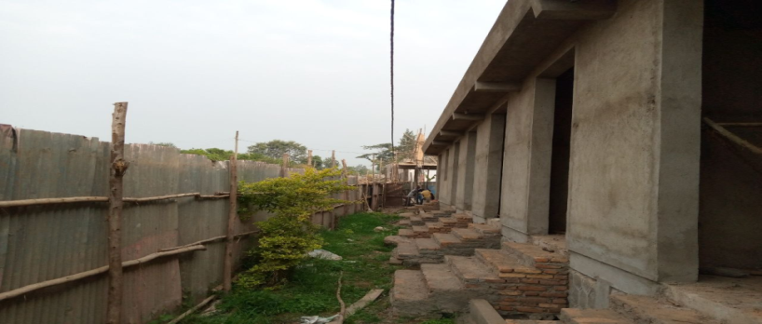

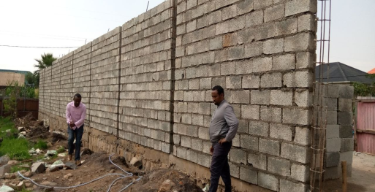
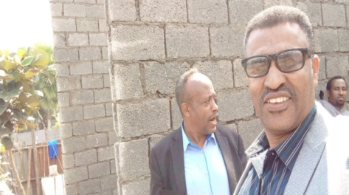
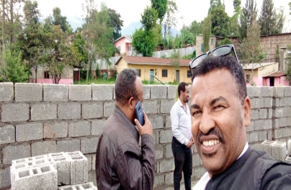

Leaders are following up MTC building work

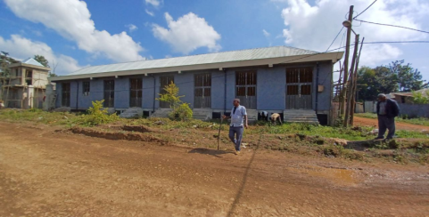
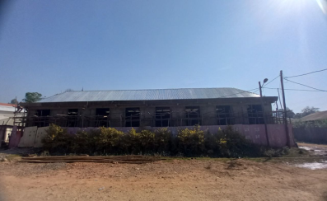
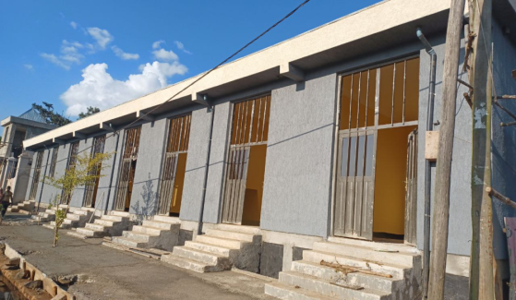
Shops are on progress

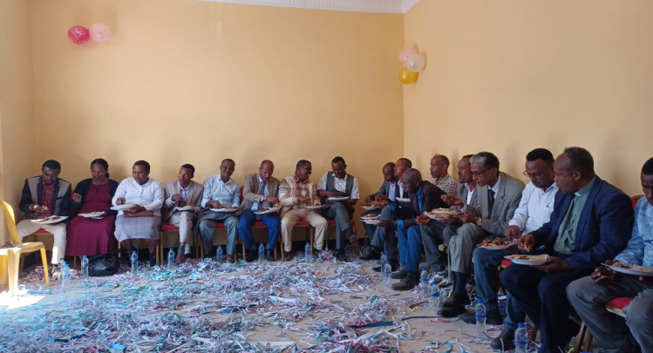
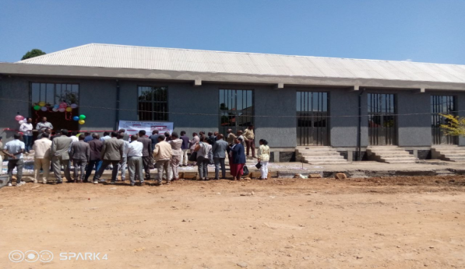
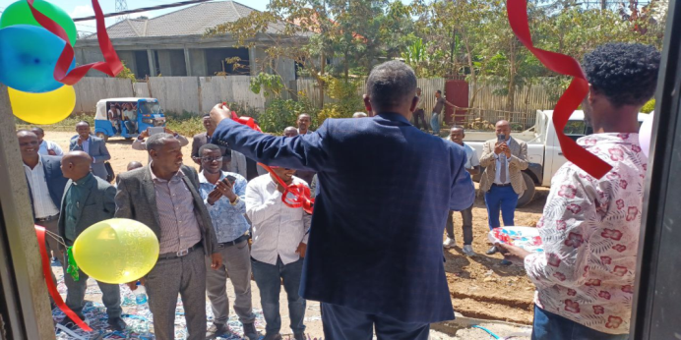
Inauguration of shops and ready for rent on November 19/2022

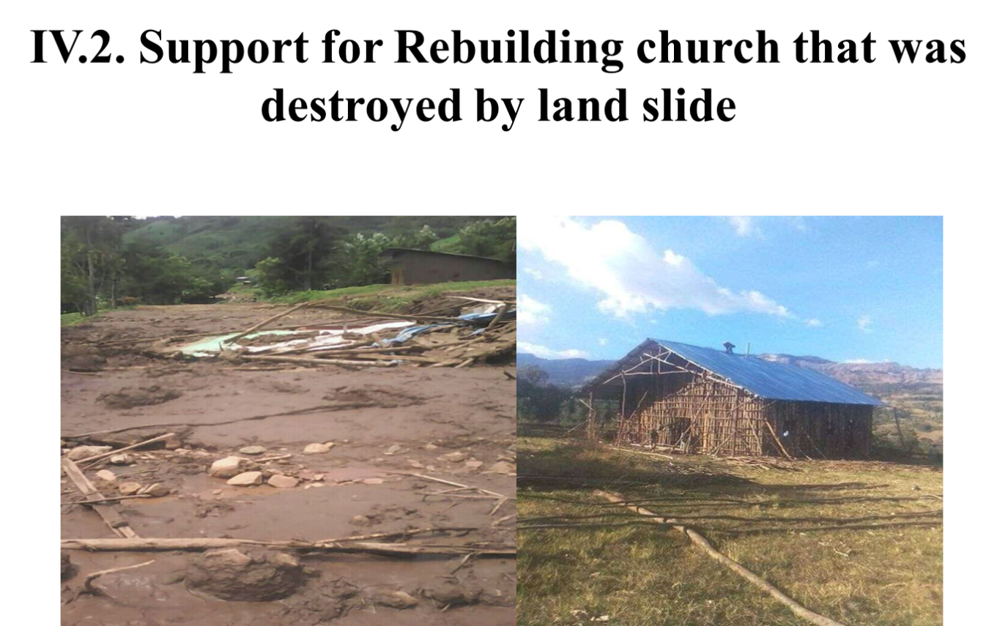

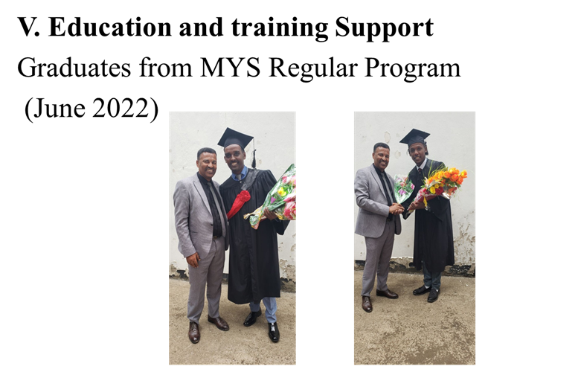

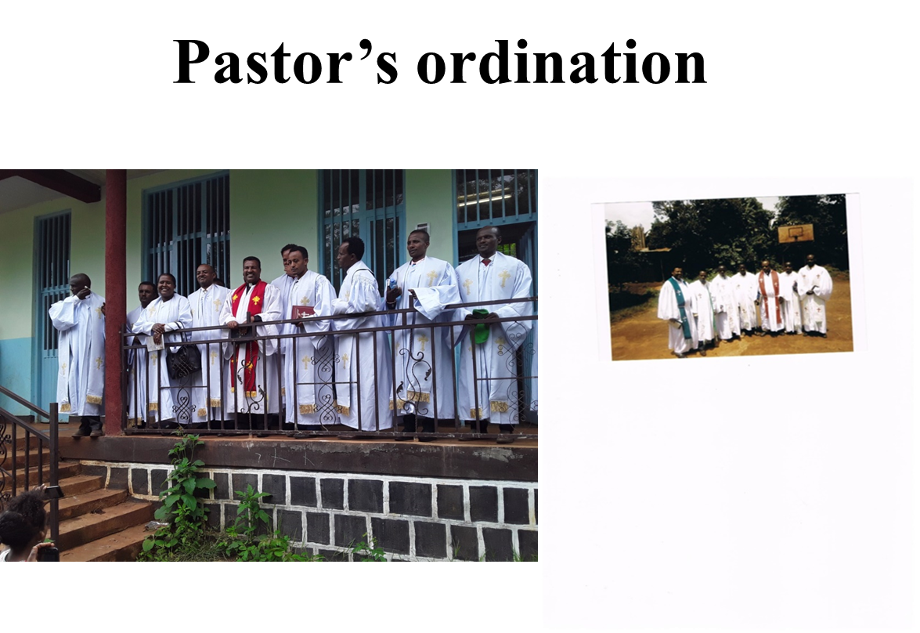

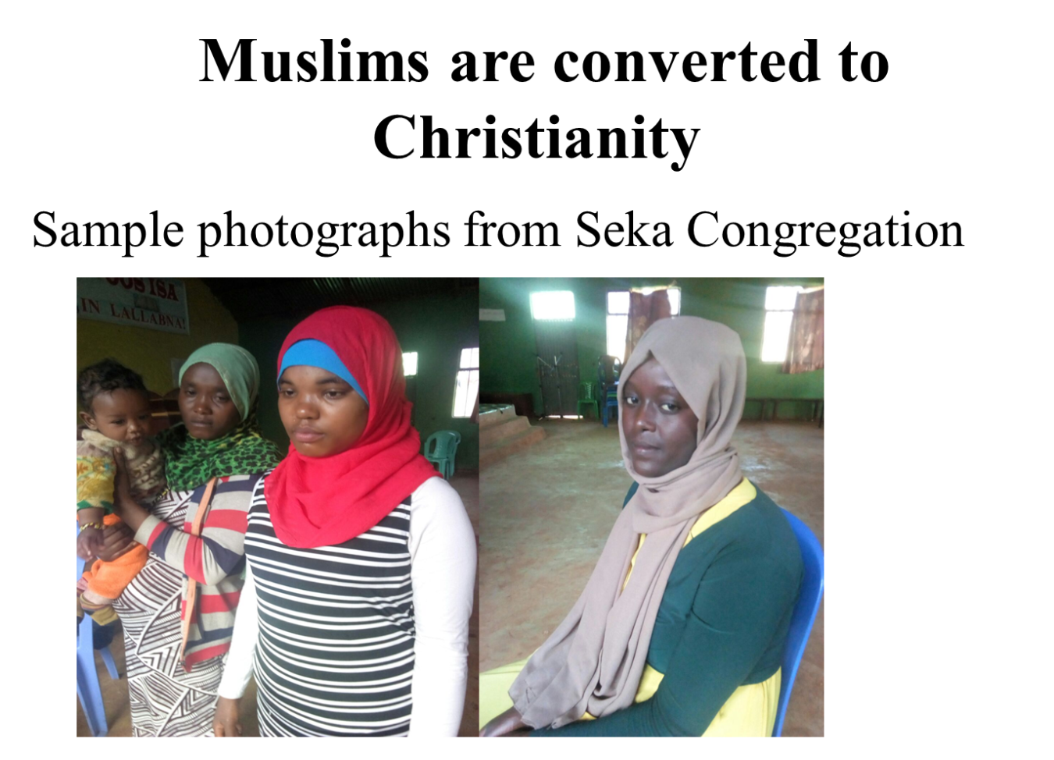

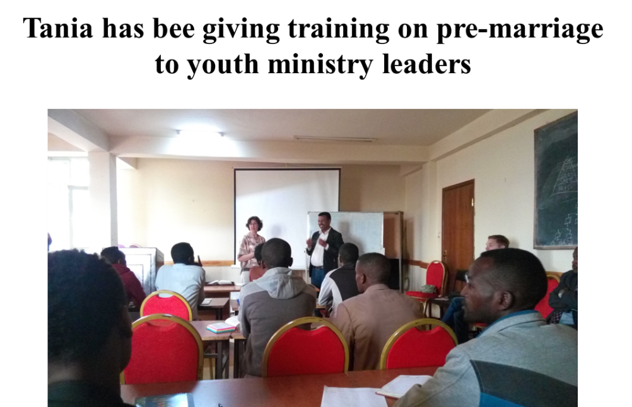

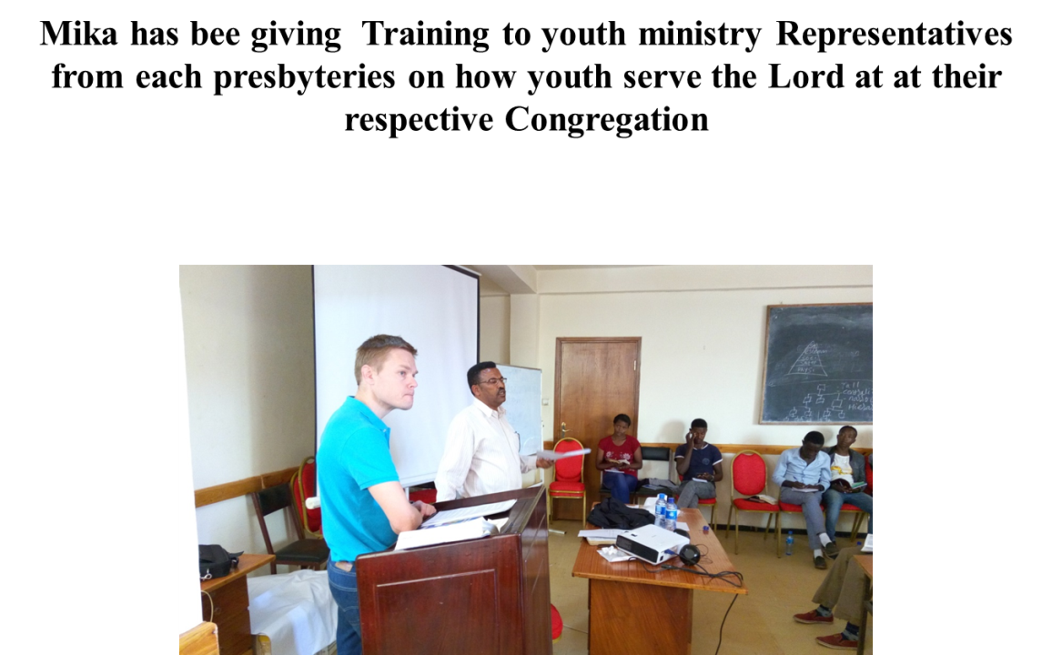

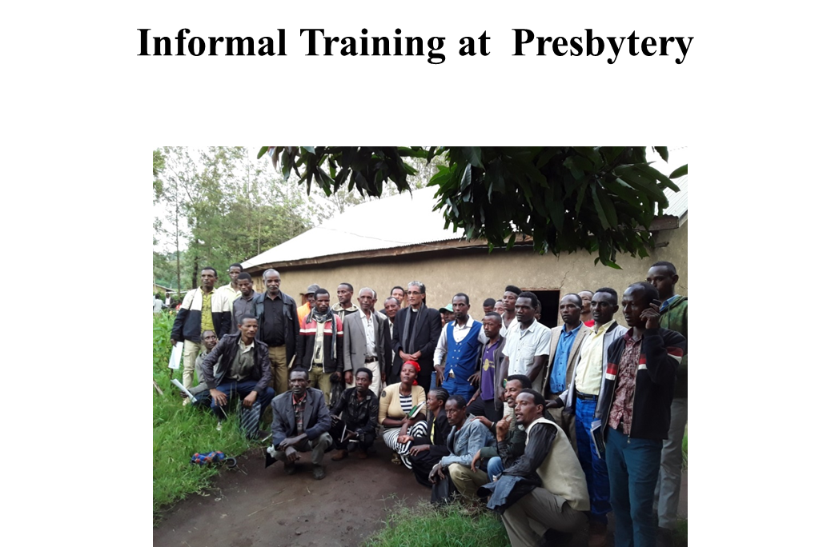

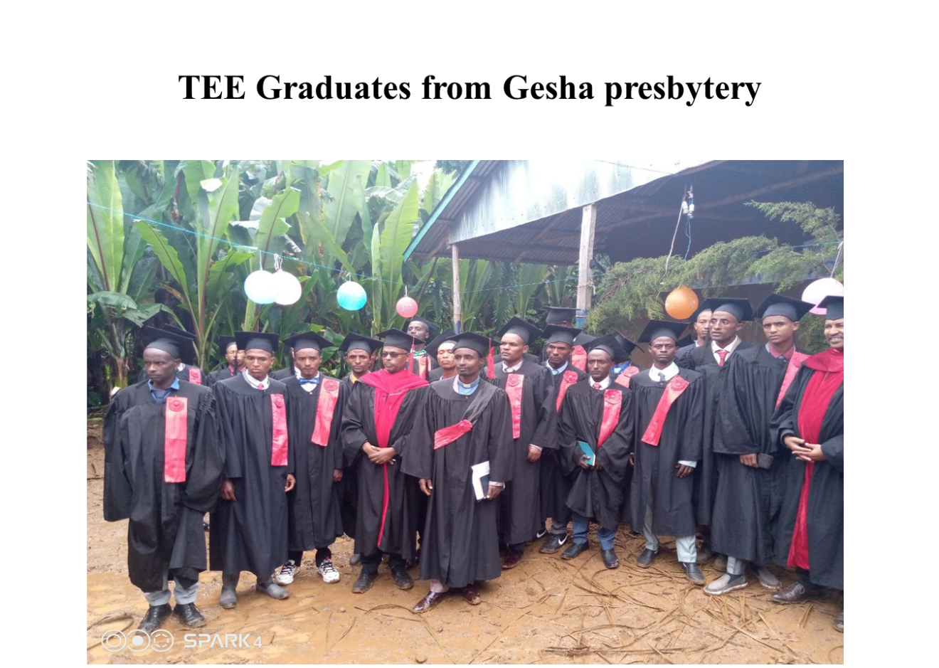

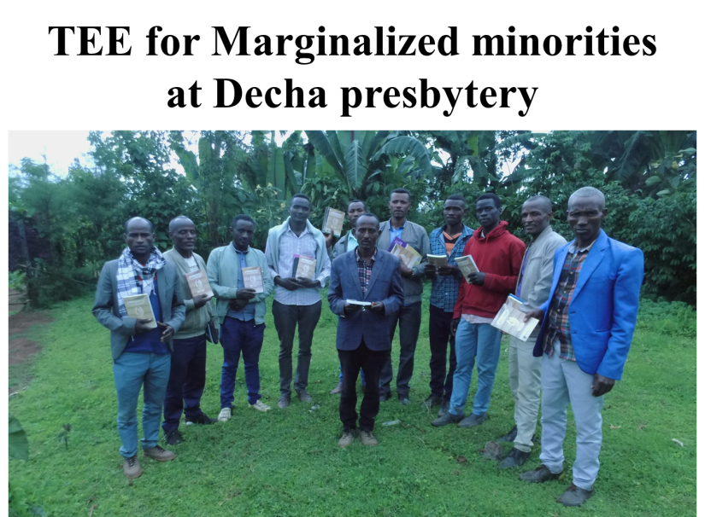

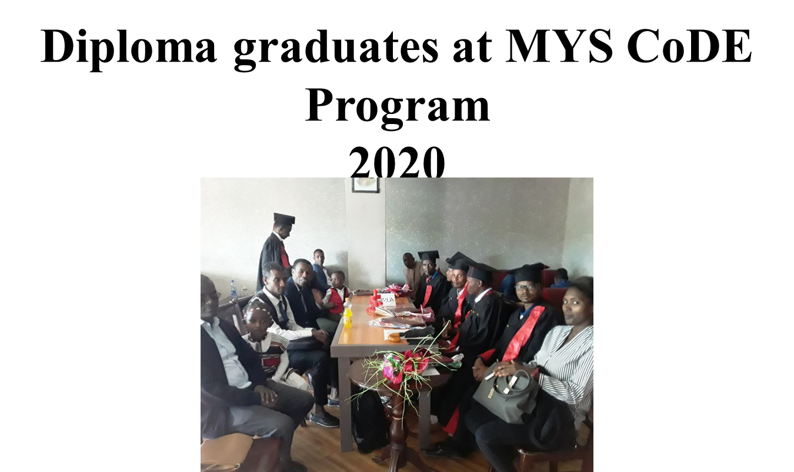
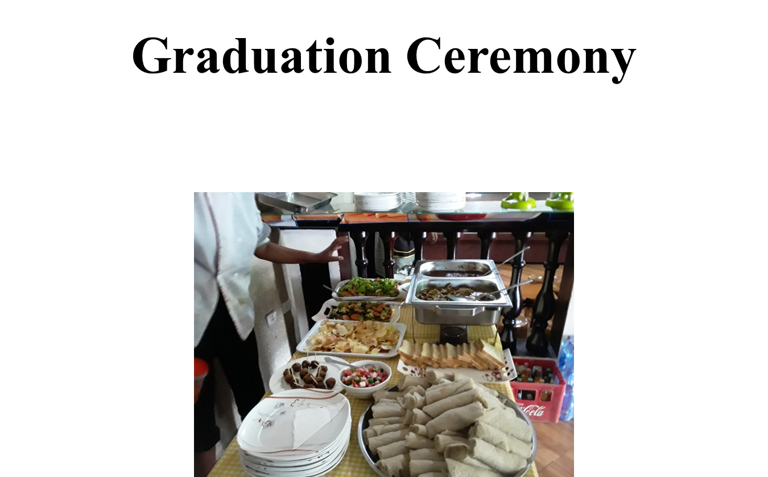

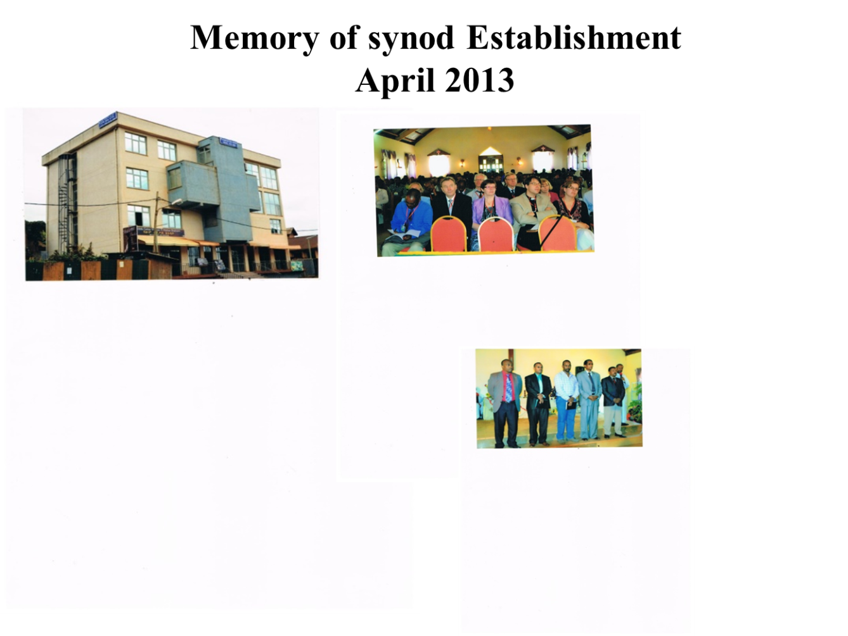
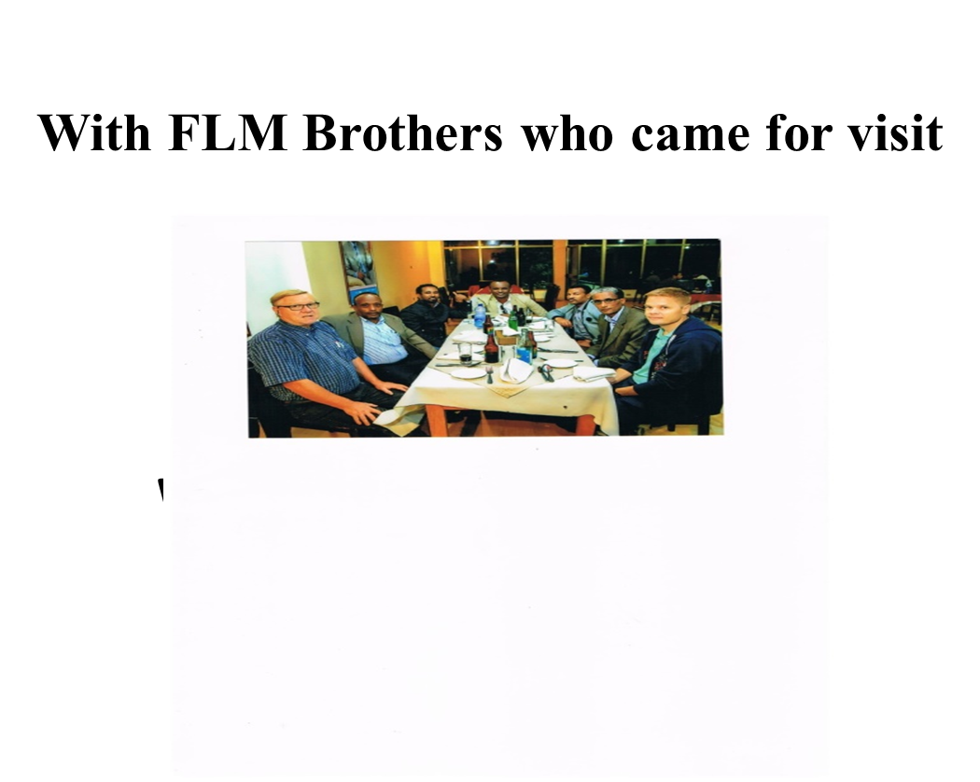

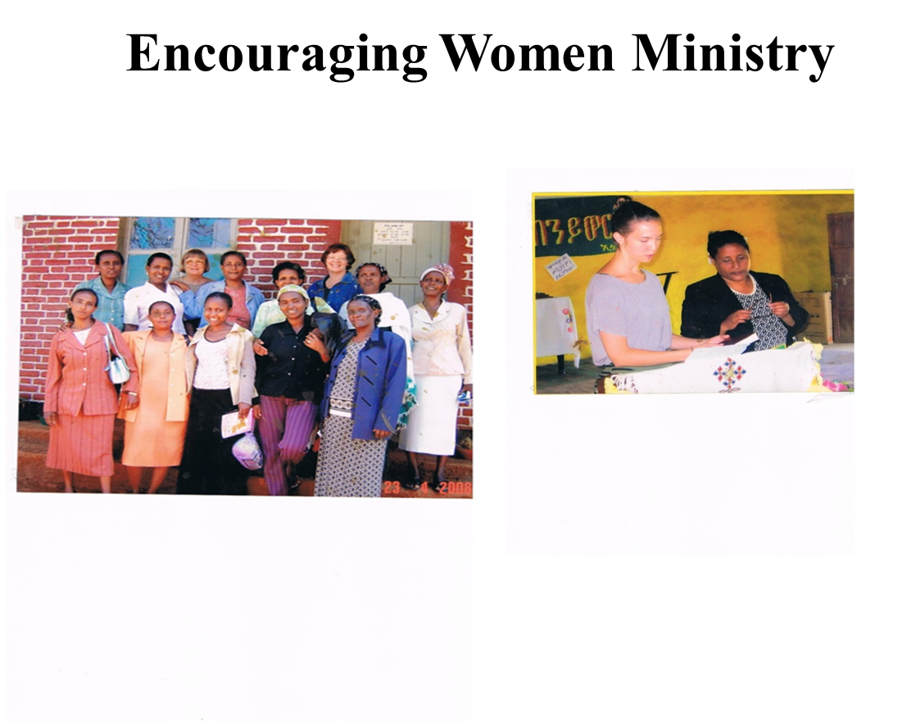
Challenges and Opportunities
Challenges
- Persecution from Muslims
- Lack of trained ministers to Serve marginalized minorities
- Lack of enough trained ministers
- Financial constraint to serve diakonia ministry
Opportunities

- Dominance of Islam particularly in Jimma Zone.
Many Muslim brothers are coming to Christ.
- Recently 25 Muslims came to Christ and baptized
- Marginalized minorities.
Namely: Manja, Nao, Chara, Bacha and Mana
- Traditional Beliefs: Satanic and fore generation belief
All these are the doors to bear witness about Christ
Words of Thanks
First and for most we would like to thank Our Almighty God for helping our synod to keep an on going growing. Next, our heartfelt appreciation goes to FLM for being beside us in all aspects of our Synod’s work. In addition, FLM is not only supporting us by funding money but also giving us brotherhood encouragements and visitations.
May God Bless FLM, the members of FLM, Lapua Diocese, their family and their country. Amen.

